Project:
Library Management System

Use Case: Search Book

Name: Muhammad Haroon
Rollno: SP23-BSE-055

Use Case Diagram:
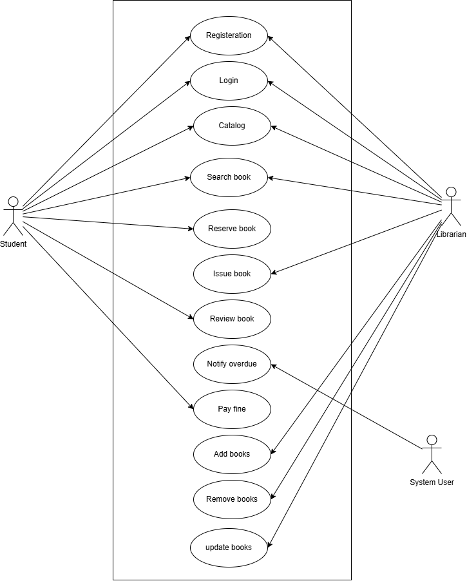

Fully Dress Use Case:
Search for book Use Case:

UseCase ID | UC-3
Use Case Name | Search for book
Actors | Librarians or student and data base/ API
Description | This use case describes the process by which a user searches for books within a library system. The system provides the user with a list of available books based on specified criteria such as what user search or looking for
Trigger | The user initiates a search for book through the library system.
Precondition | - The user has access to the library management system.  - The user is logged in  - The library database/API is accessible and up-to-date.
Postconditions | - The user receives a list of available book matching the specified criteria.  - The user can proceed to view detailed information about each book
Normal Flow | - The user accesses the library system and selects the option to search for books.  - The user enters search criteria including author, book title and any specific preferences (e.g., price).  - The system retrieves book information from the database/API based on the provided criteria.  - The system displays a list of available books along with basic details such as name, price, and ratings.
Alternative Flows | - If the user's search criteria yield no results, the system notifies the user and suggests adjusting the search parameters.  - If the user decides to modify their search criteria, they can return to the search form and make changes before re-submitting the search.
Exceptions | - Technical issues prevent the system from accessing the database/API, in which case the system notifies the user of the problem and advises them to try again later.  - Invalid search criteria inputted by the user result in an error message prompting them to correct the information.
Business Rules | - Library displayed must meet the user's specified criteria.  - The system should prioritize displaying accurate and up-to-date information about books.  - Prices displayed should reflect the current rates and any applicable discounts or promotions.
Assumptions | - The library system has a reliable connection to the library database/API.

SSD for Search BOOK
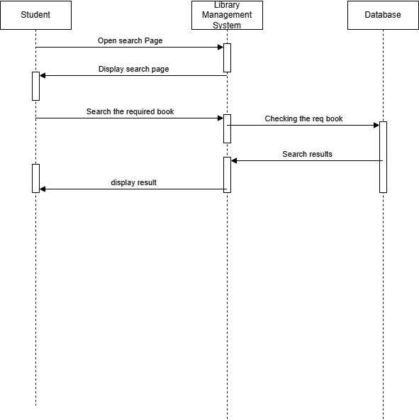

Class Diagram:
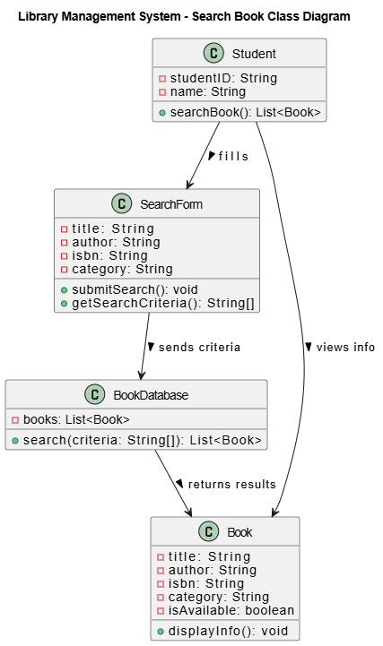

Operational Contract:
For Search Book:

ID | 3
Name | Search book
Cross Reference | Use Case – Search for Book
Pre Condition | The user must be logged in as a Student.
Post Condition | - The system returns a list of books matching the criteria.  - Search results are displayed to the student
Object Involved | - Student  - Search Form  - Book  - Book Database

